LoadRunner 12.50 community edition can be download using below link.
https://drive.google.com/file/d/1rjP9r9hoLBF2Qph-wltgyJzH3O7IwRoi/view?usp=sharing

LoadRunner 12.53 Link community edition can be download using below link.
https://drive.google.com/file/d/1IXX216HfZUp_jorRRQ65ClR_R9h6k9EK/view?usp=sharing

Instructions:

1) Switch Off the windows Firewall

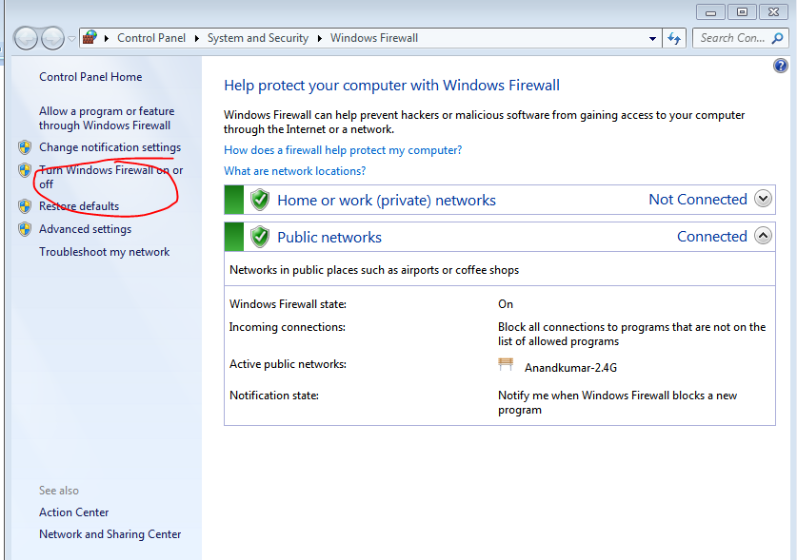

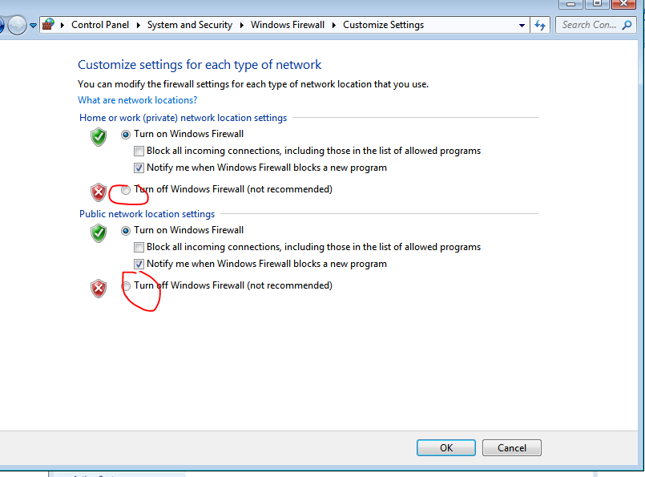
2) Turn off the Anti-Virus
3) Click on the link
https://drive.google.com/file/d/10GVWdAG9qfIsQzyyB4ipBaN4xICKQXI8/view?usp=sharing

4) Click on Download
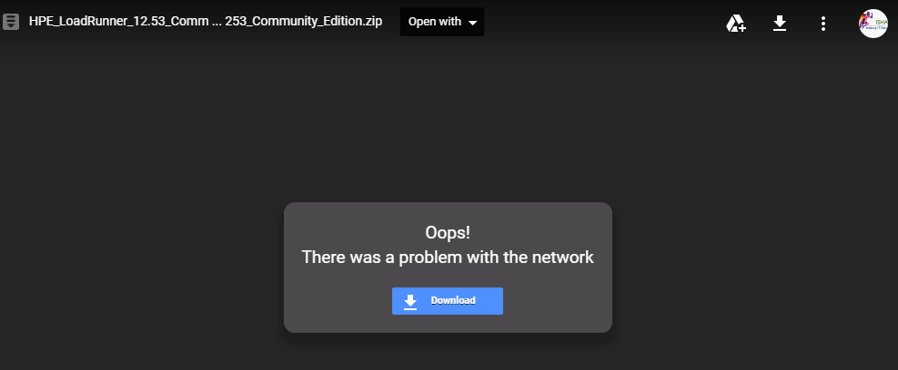

5) Once the file is downloaded, go ahead and install the tool.
6) Use the "Typical Mode" when prompted during installation.
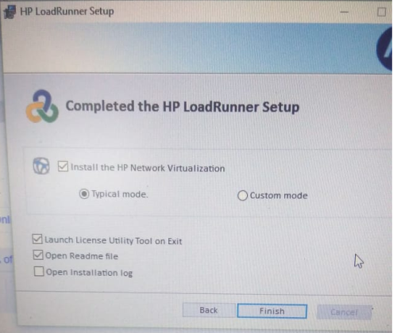

Common issues that you might encounter:

After you have downloaded and while you are installing, you would see below window.

Pls un-check the marked option.

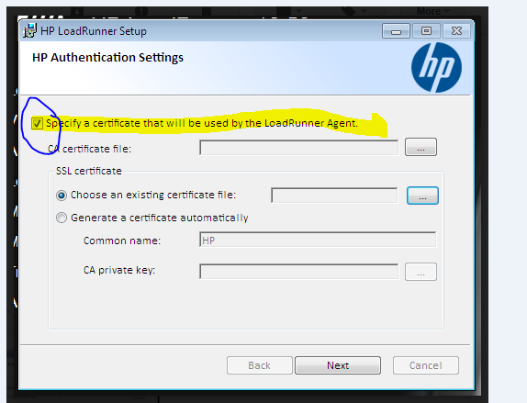

2) "Error writing to a file"
Before you install the tool, pls turn off the anti-virus. Even if the below problem persists, then turn off the firewall as well
